**Happiness Score Analysis Country wise from years 2015-21**

Applied Data Science Capstone by IBM/Coursera

Author- Monika Sarswat

Table of Contents-

1. Introduction- Business Problem
2. Data Acquisition and Cleaning
3. Exploratory Data Analysis
4. Best affective feature
5. COVID-19 Effect on Happiness
6. Results and Conclusion

Introduction- Business Problem

Happiness Score looks like just the mathematical representation of how happy a country’s people are, while it is far too deep than that, in this report we will see what is in those numbers which tells us a lot more than just happiness.

* The main features of a country and region which make their people happy or sad…everybody wants to know.
* These may include many among political, economical and natural environment of a country.
* Everyone wants to know how the COVID-19 pandemic has affected their people around the world.
* And along with the continuous change in other features where in the future our country seems to be in the range of happiness of it’s people.

People, in general, wants to know the reasons related to particular happiness score for their own country or any country, why a country like Finland always seems to be more happy than average and other countries are more volatile. This report helps in understanding the Happiness Score’s different features along with-

* Wide analysis on Happiness Score From years 2015-2021 including each world country’ data.
* Finding the main Features impacting the most on happiness score.
* COVID-19 effect on world’s happiness.

Data Acquisition and Cleaning

The data has been taken from Kaggle for all years. The final dataset was made by combining all years data from 2015 to 2021 and containing columns which include the feature and label columns only.

Final dataset contains 1084 rows and 10 columns. The columns show the features like-

1. Country Name
2. Happiness Rank
3. Happiness Score
4. Economy (GDP per capita)
5. Family (Social Support)
6. Health (Life Expectancy)
7. Freedom to make life choices
8. Trust (Government Corruption)
9. Generosity
10. Year Name

The map showing the country name along with the happiness rank based on average happiness score from all years.

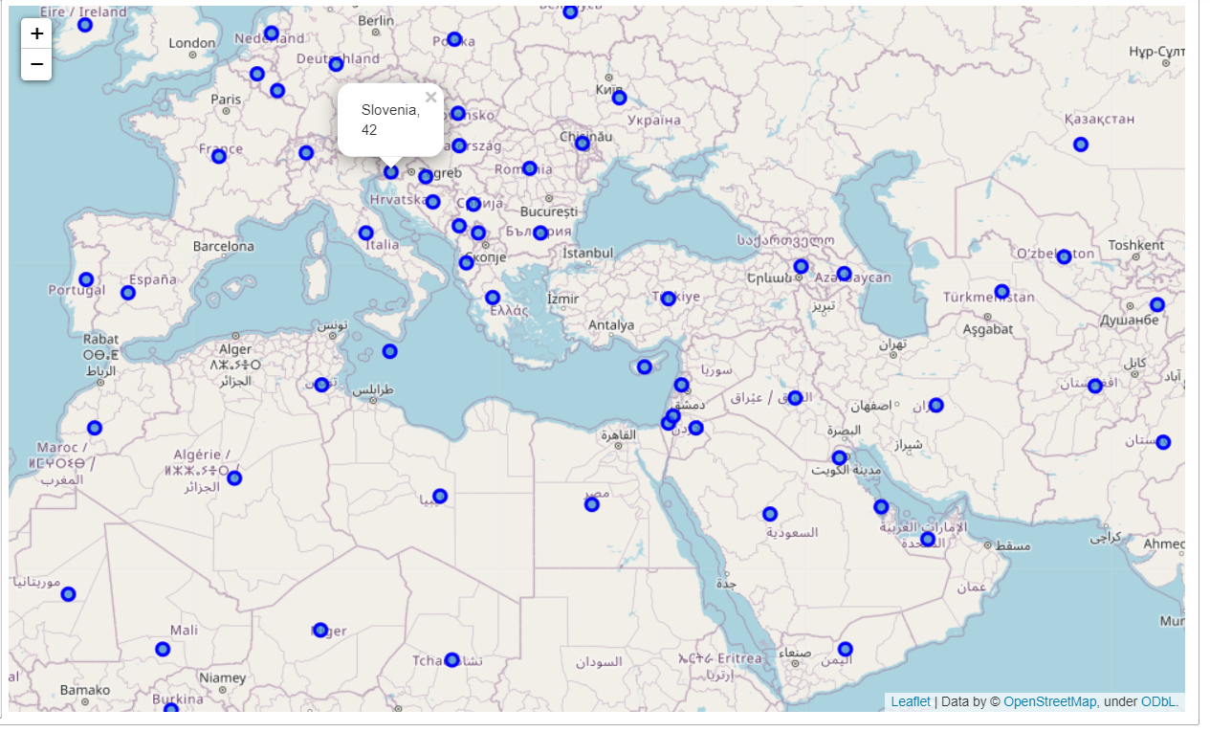

The 2015 data set showing the top 5 countries in happiness rank, where Western Europe dominates.

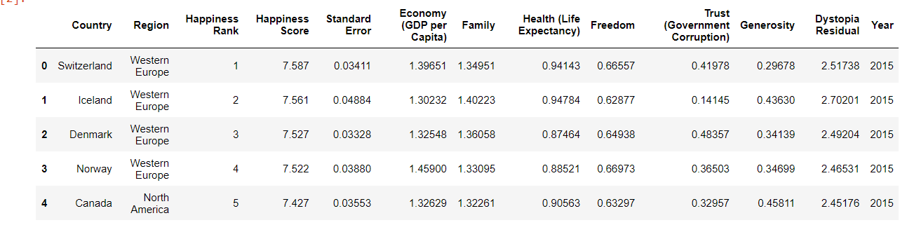

The bottom 5 countries where the Sub-Saharan African region dominates.

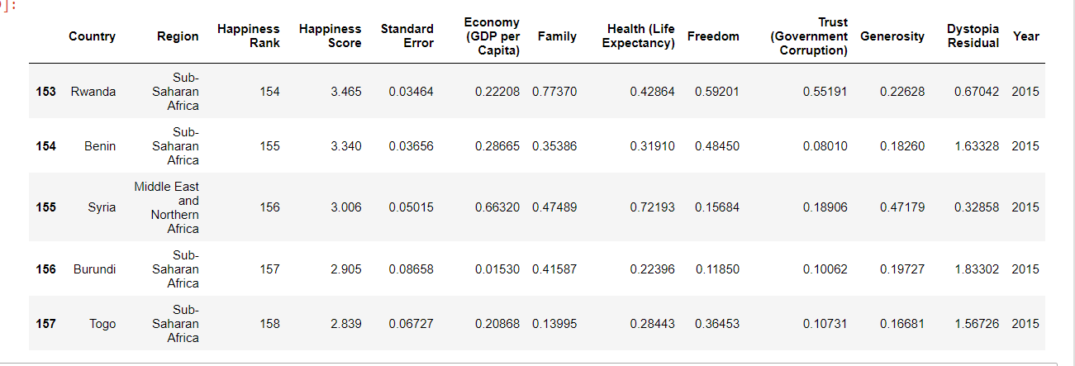

Exploratory Data Analysis

Comparing all the features, how they have changed from years and the overall country performers on the basis of each feature throughout 2015-21.

1. Top and Bottom 5 countries based on average happiness score throughout these years-

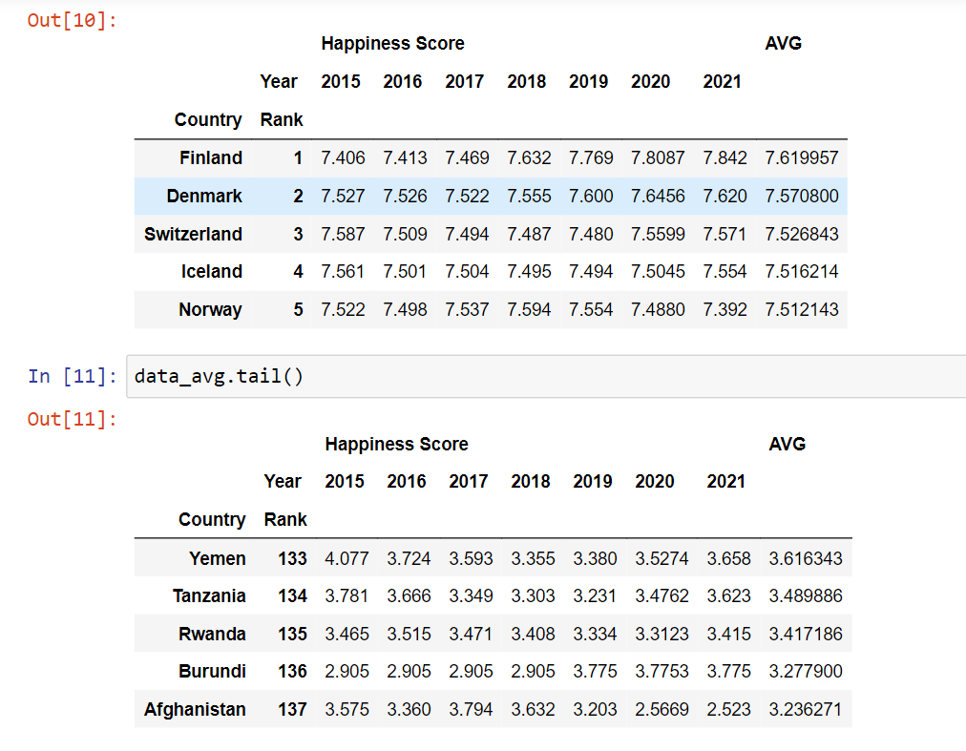

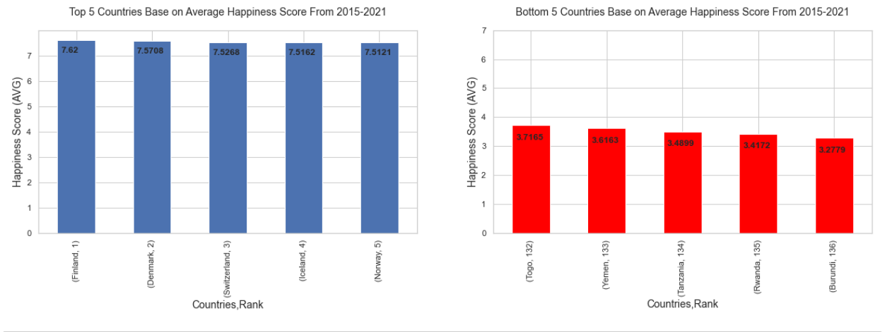

1. Top and bottom 5 countries based on average Economy Score throughout the years-

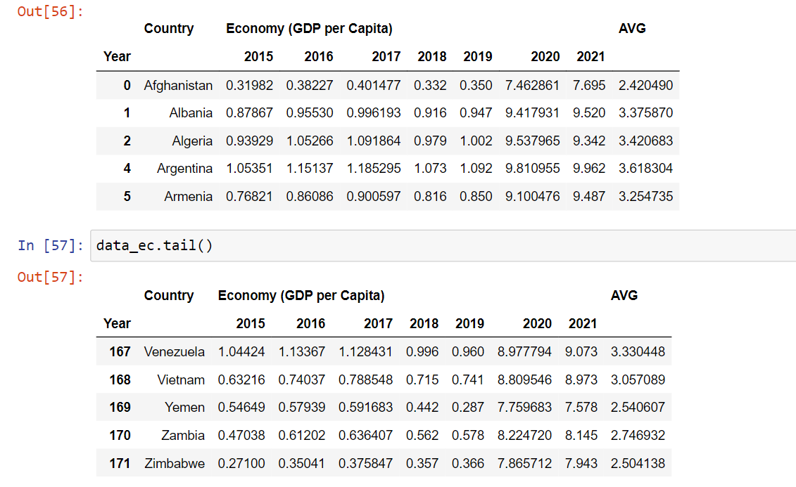

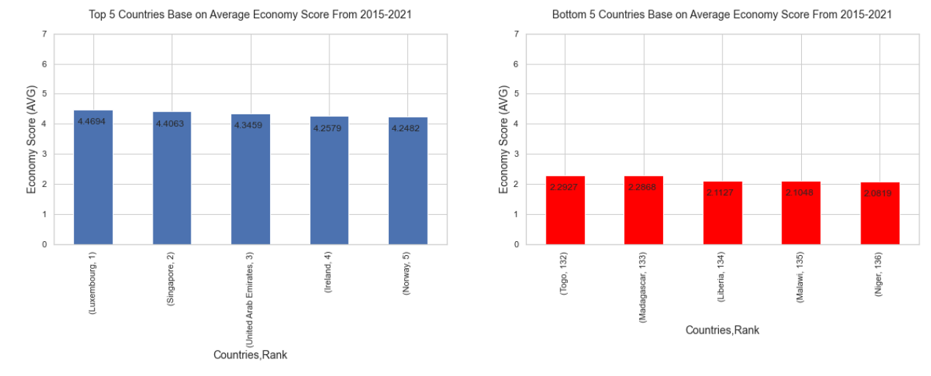

1. Top and bottom 5 countries based on average Family/ Social support score throughout the years-

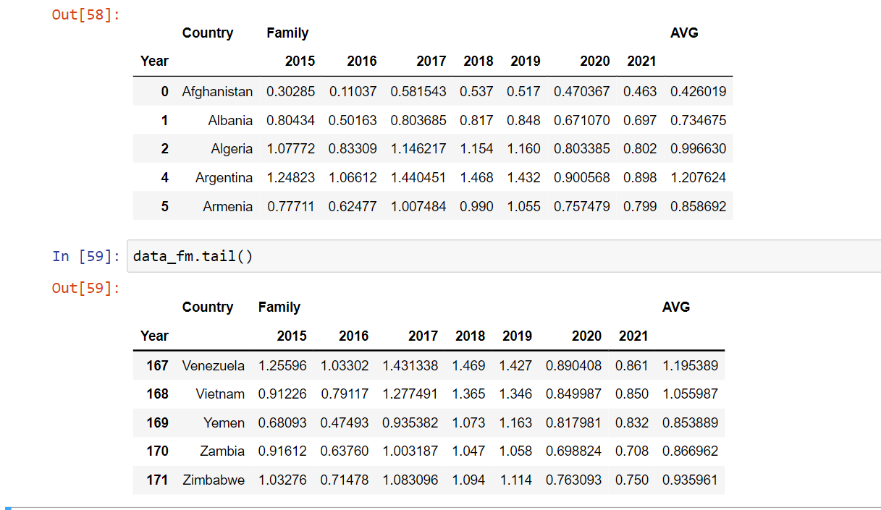

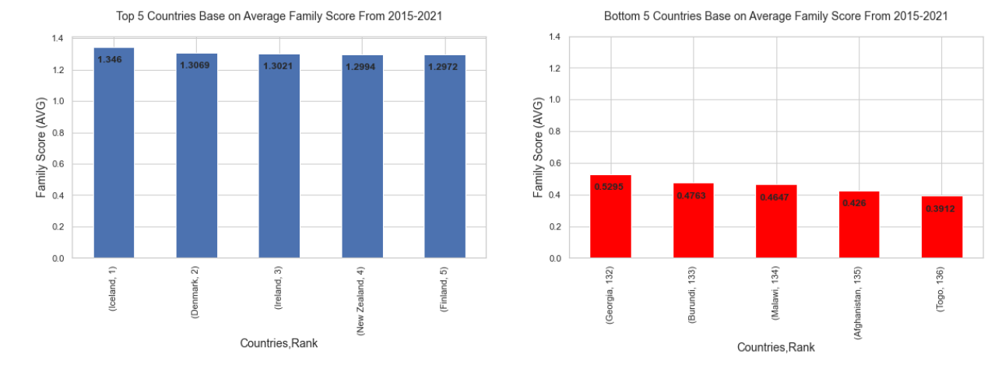

1. Top and bottom 5 countries based on average Health score throughout the years-

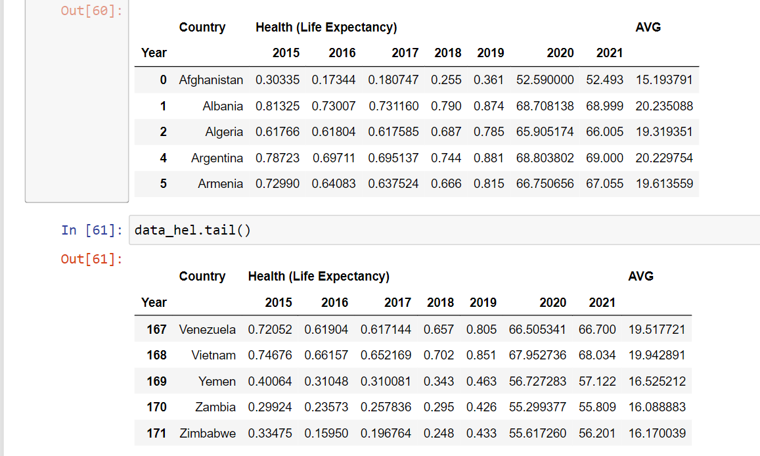

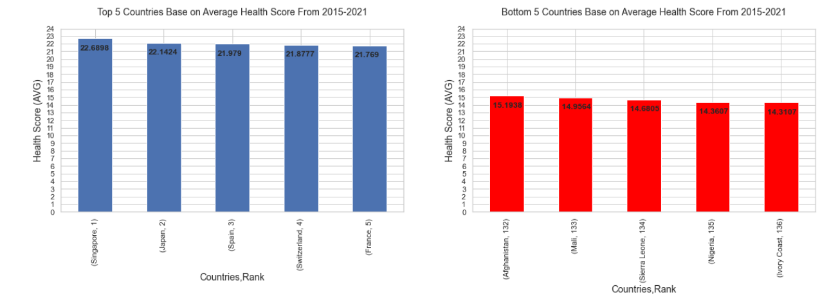

1. Top and bottom 5 countries based on average freedom score throughout the years-

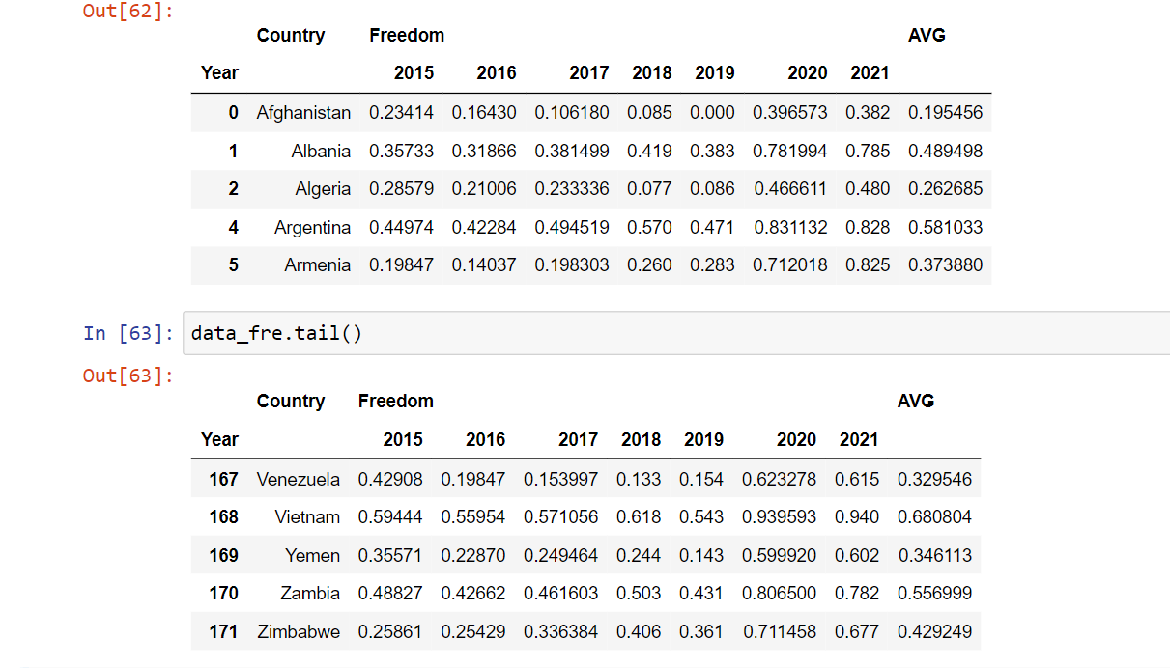

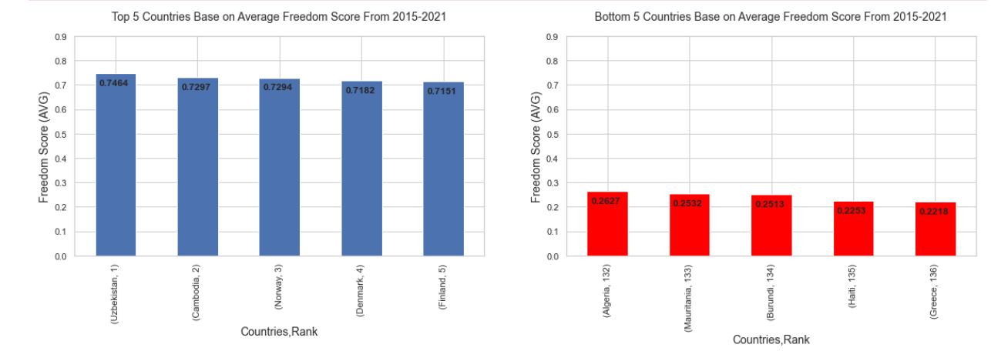

1. Top and bottom 5 countries based on average Trust (government corruption) score throughout the years-

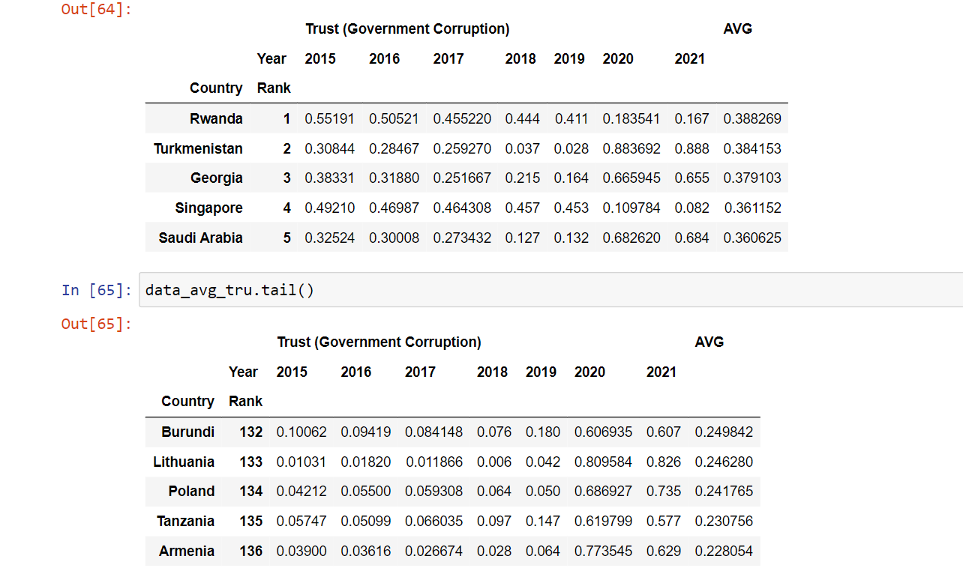

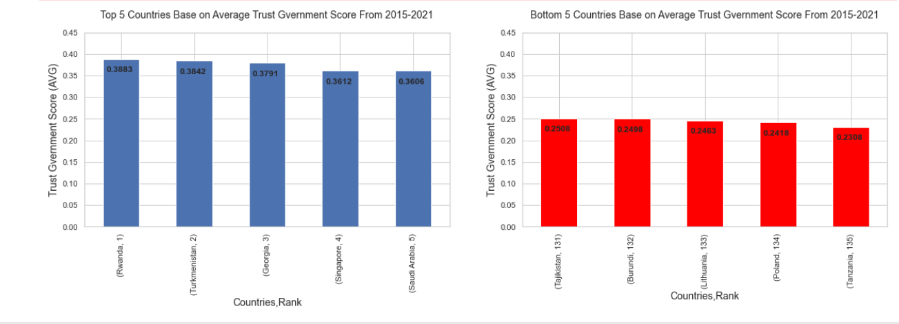

1. Top and bottom 5 countries based on average generosity score throughout the years-

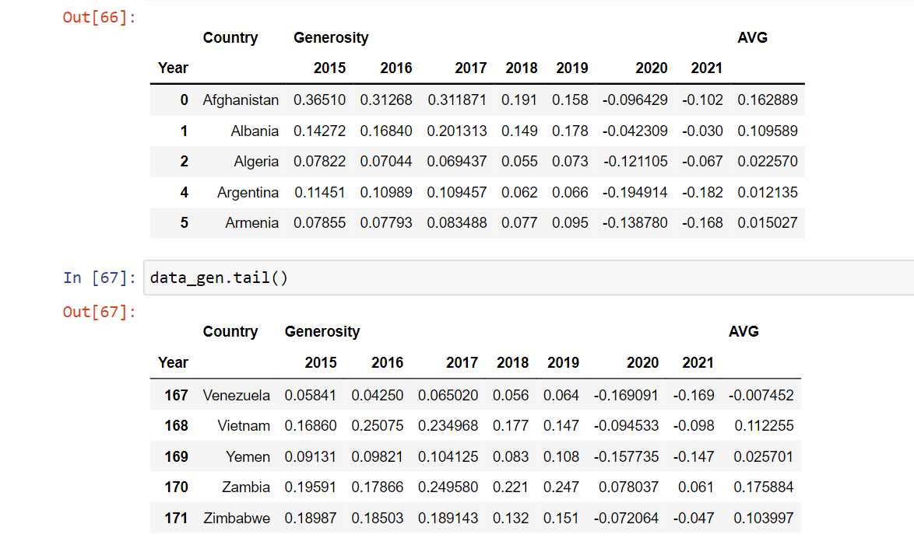

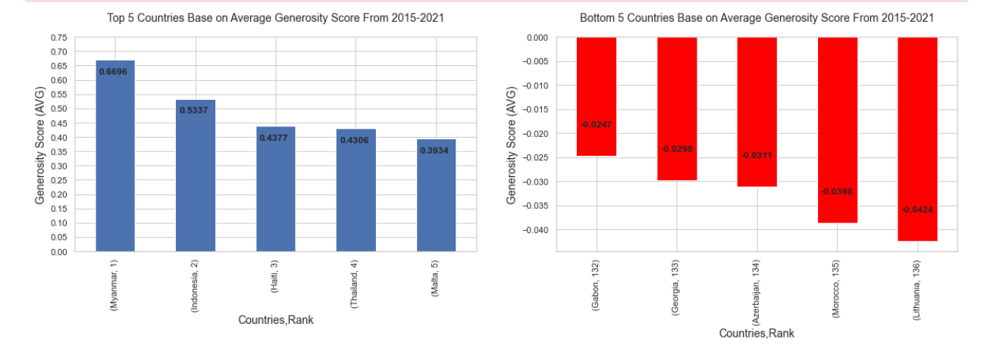

Best Affective Feature

Correlation between all features shows how much they are related, to dig deeper we can take help from Pearson Correlation Coefficient, But here we just simply used pandas inbuilt function corr().

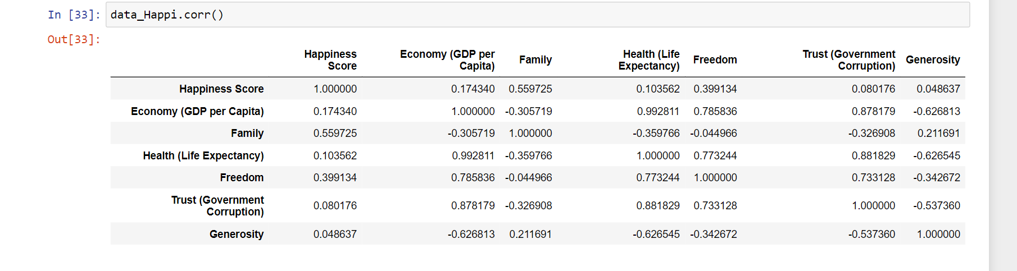

The function shows that most effective feature for happiness score is family/social support for people to each other and then the features like freedom to make life choices, GDP per capita of country, Health score of country, Trust of people on government and generosity between people, affect the happiness score respectively.

COVID-19 Effect on Happiness of World

To know more about the pandemic effect on world’s happiness, I first merged the datasets of 2020 and 2021 and created a new dataframe of these two years and then added columns like percentage change in values of features for every country from 2020 to 2021, how much they have changed.

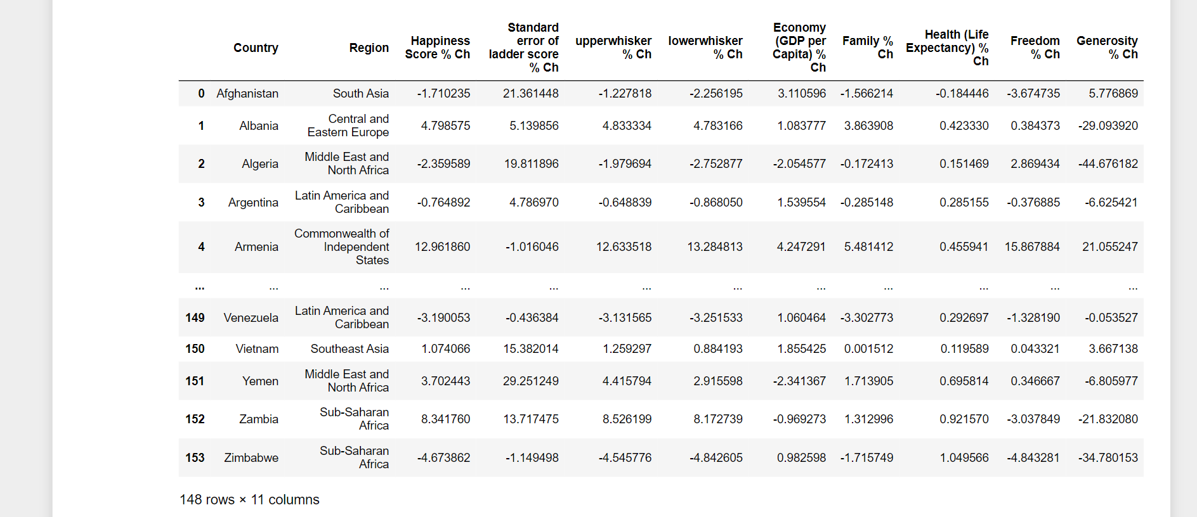

The top and bottom 10 countries based on happiness score of 2020 and 2021-

2020-

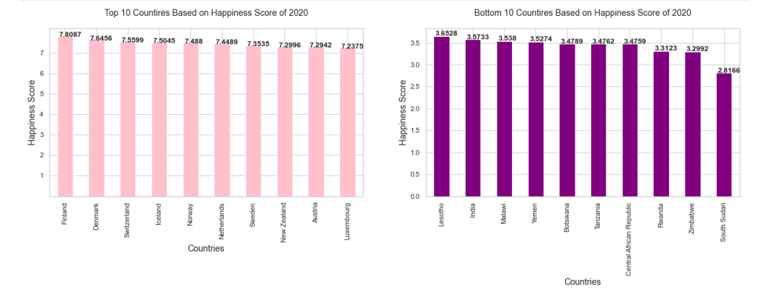

Top 10 countries of 2020-

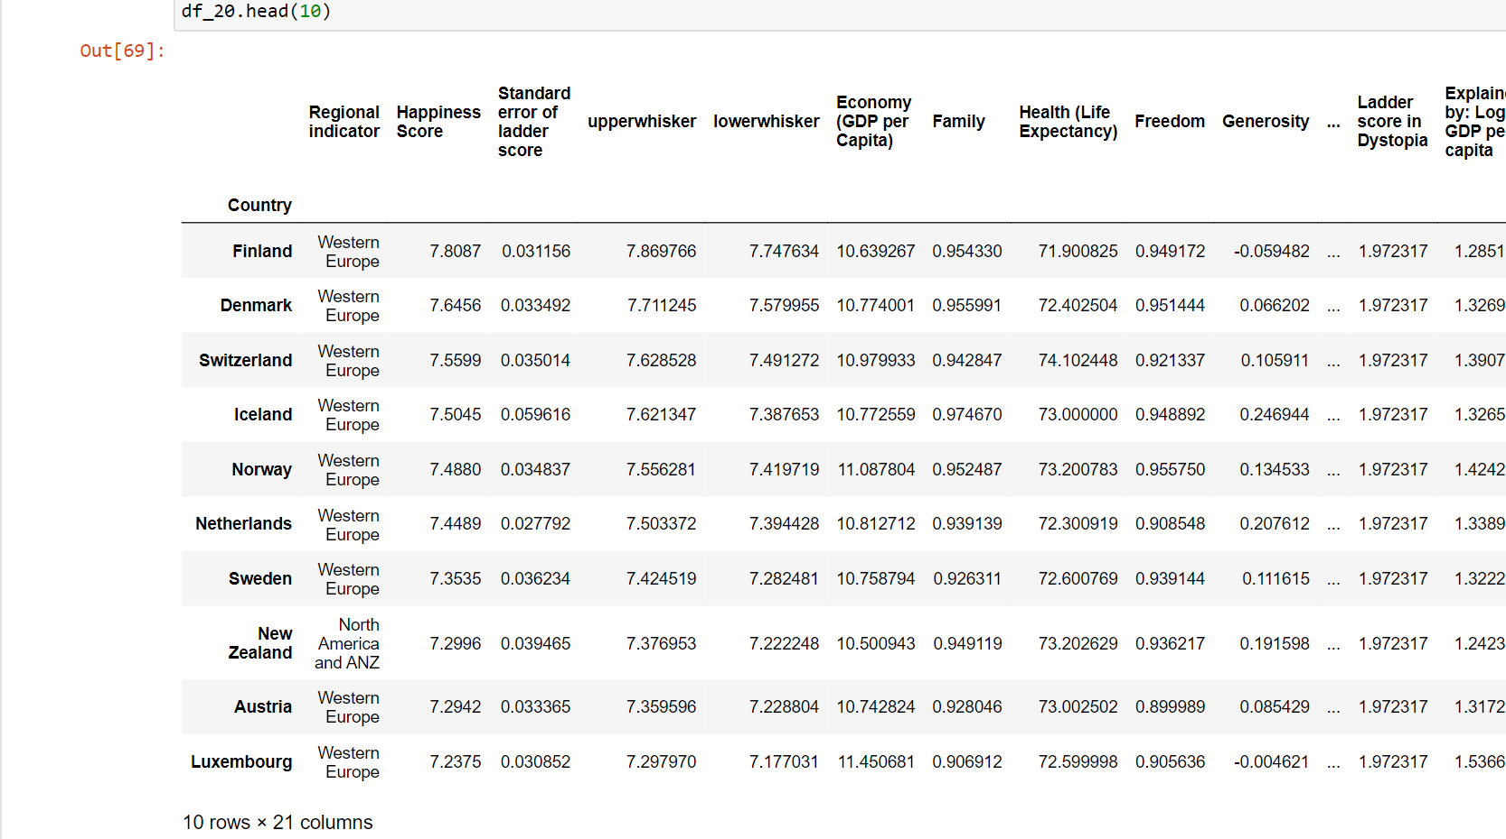

Bottom 10 countries of 2020-

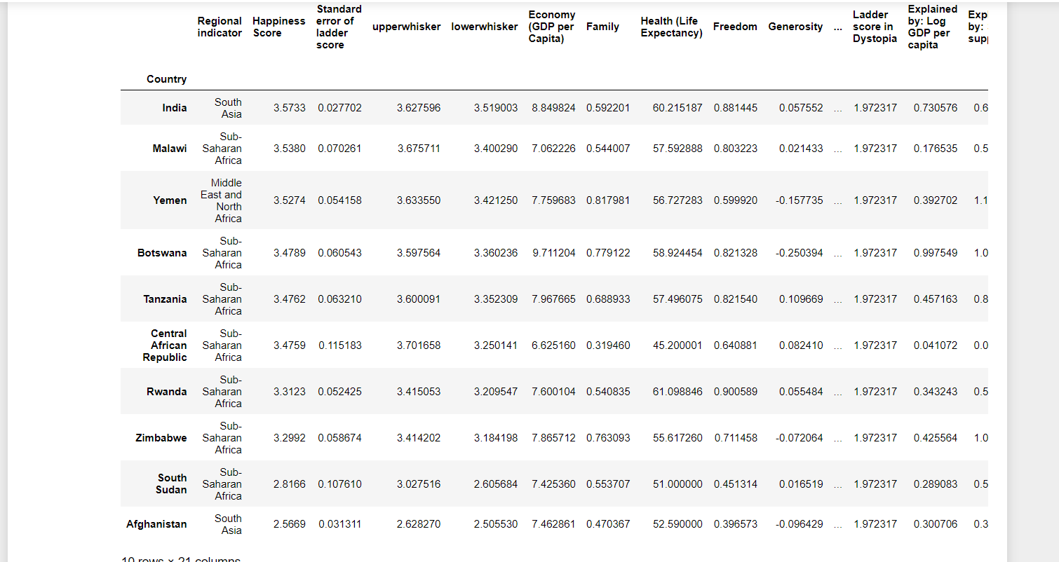

2021-

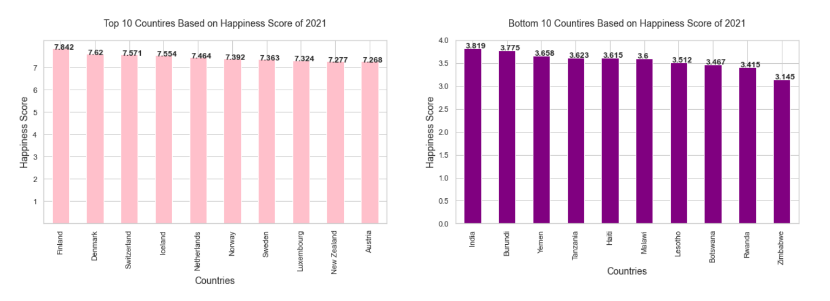

Top 10 countries of 2021-

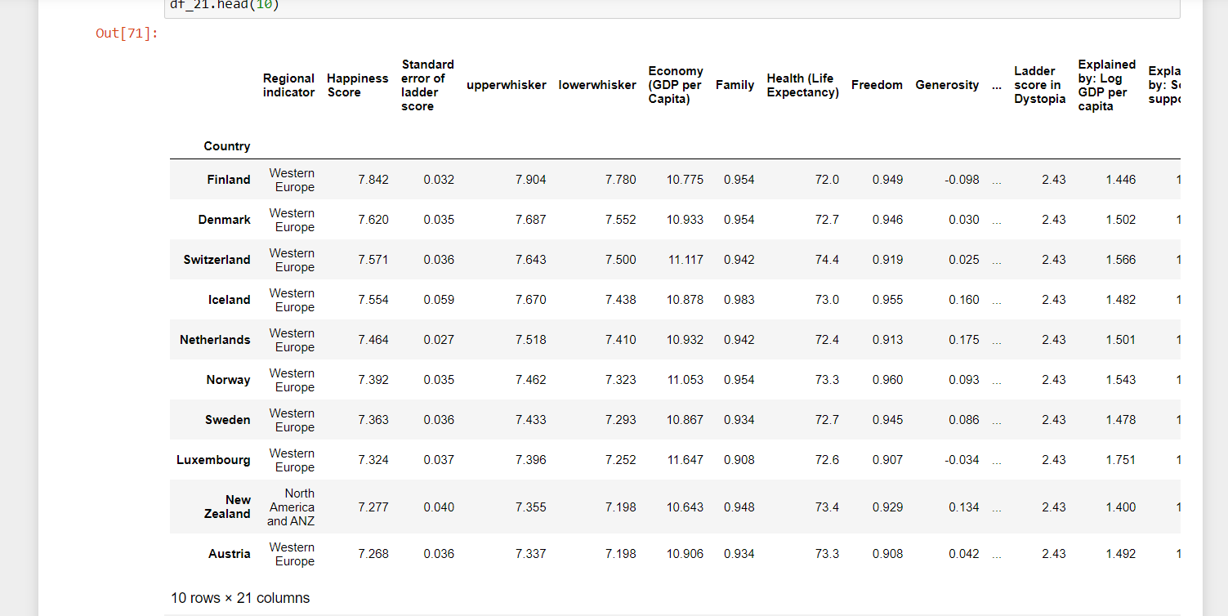

Bottom 10 countries of 2021-

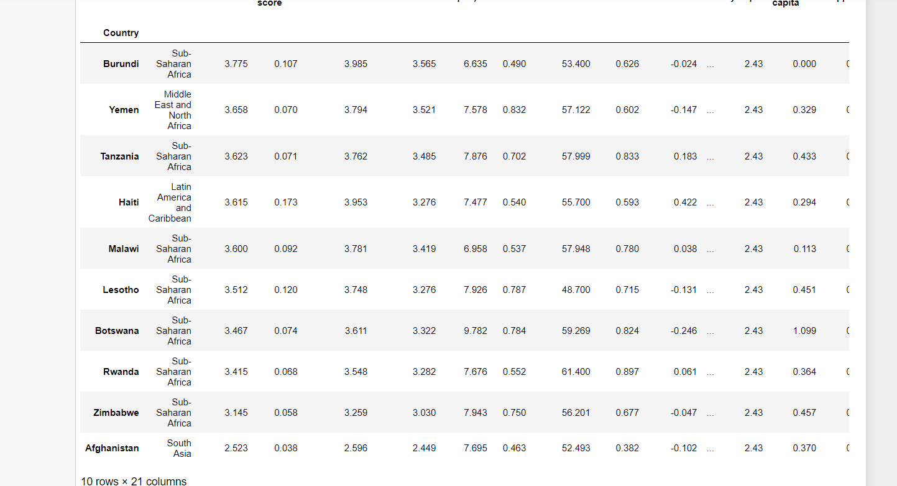

I created the choropleth maps showing the value of different features in year 2021 and the percentage change between these two years.

And also the pie-chart showing the countries affected positively and negatively due to COVID-19 pandemic.

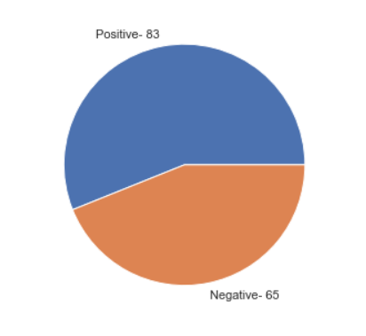

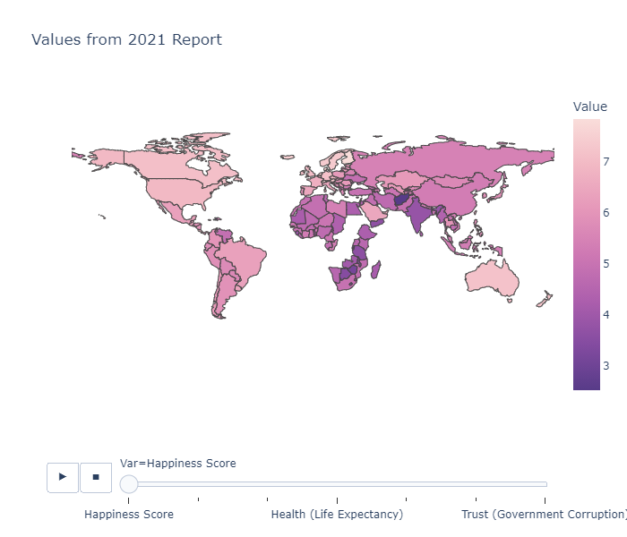

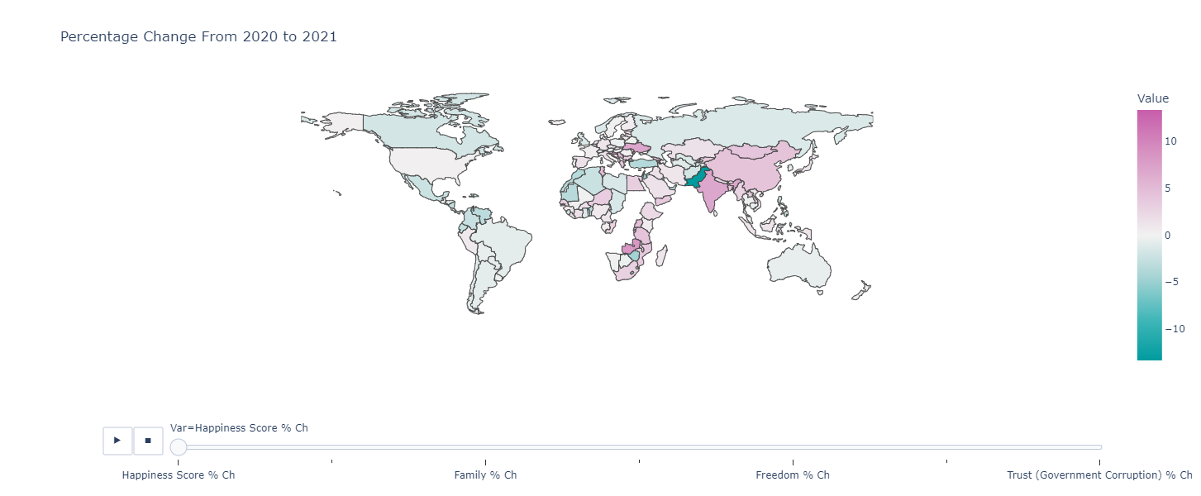

Results and Conclusion

* The Happiness Score not only the people’s moments of happiness, I think it shows lot more than that including different aspects like how generous the country’s people are, how well is country doing in economic sector, how safe, free and supportive the people feel there, how much their own people trust their government, how healthy there people are.
* The all features overall equally affects the people’s happiness but the main factor is family and social support of people to each other.
* The COVID-19 crisis affected the countries’ happiness score almost equally in both ways positively and negatively and people’s positive thinking and hope for future is definitely main factor for a country’s happiness score.